MongoDB – Complex Queries

Mongo DB Exercises - With the Restaurants Data Set

- Download the restaurants.zip file

- Unzip the file, you will see restaurants.json file

- Run the mongod server
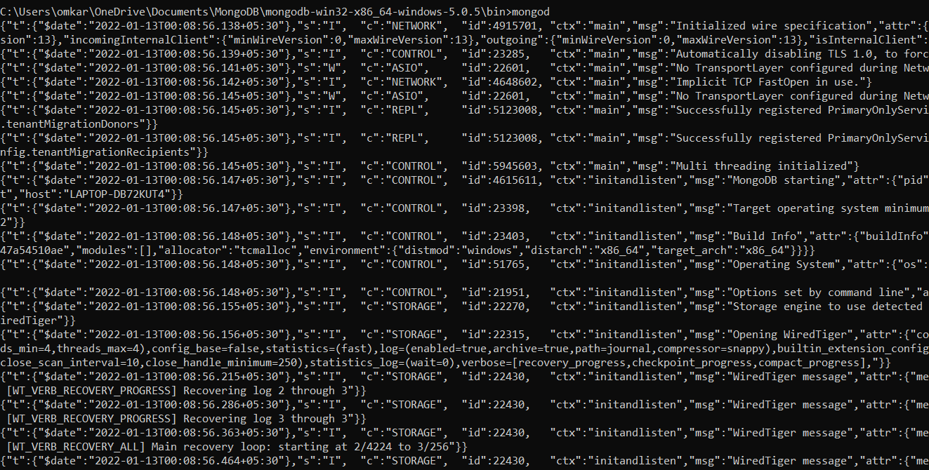

- Run the following command to import the json file provided. It will load the json file into the mongodb with database name - restaurants, collections name - addresses

mongoimport --db restaurants --collection addresses --file restaurants.json
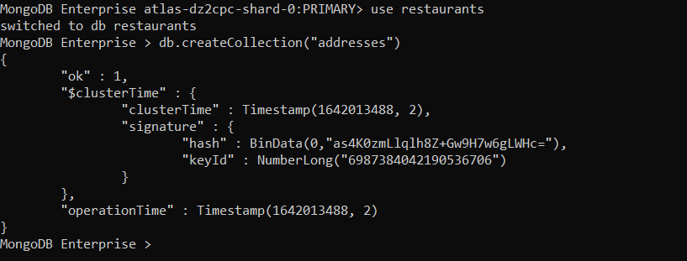

- Run mongo shell command

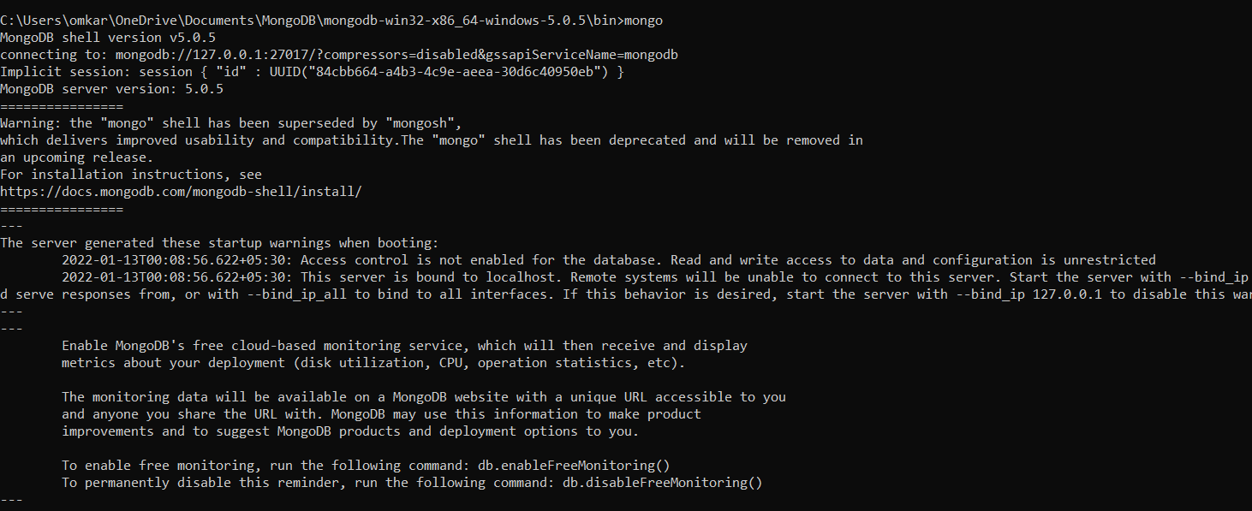

- show databases
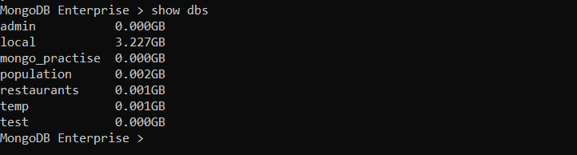

- use restaurants
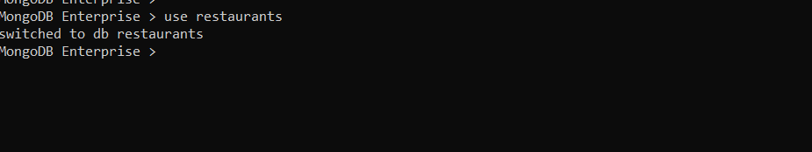

- db.addresses.find() should print entire json data

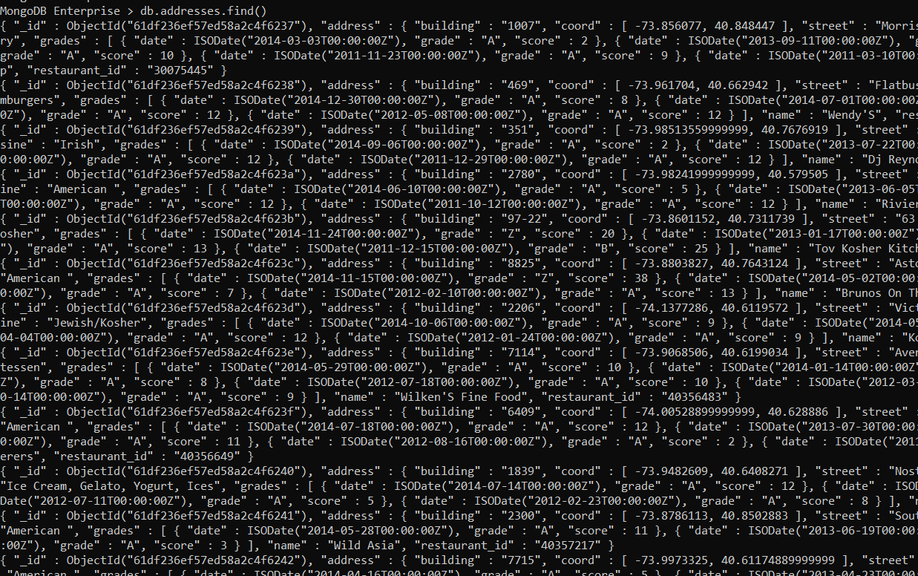

- Then start working on the following exercises and submit your queries as the answers to the questions

Exercise Questions

- Write a MongoDB query to display all the documents in the collection restaurants.

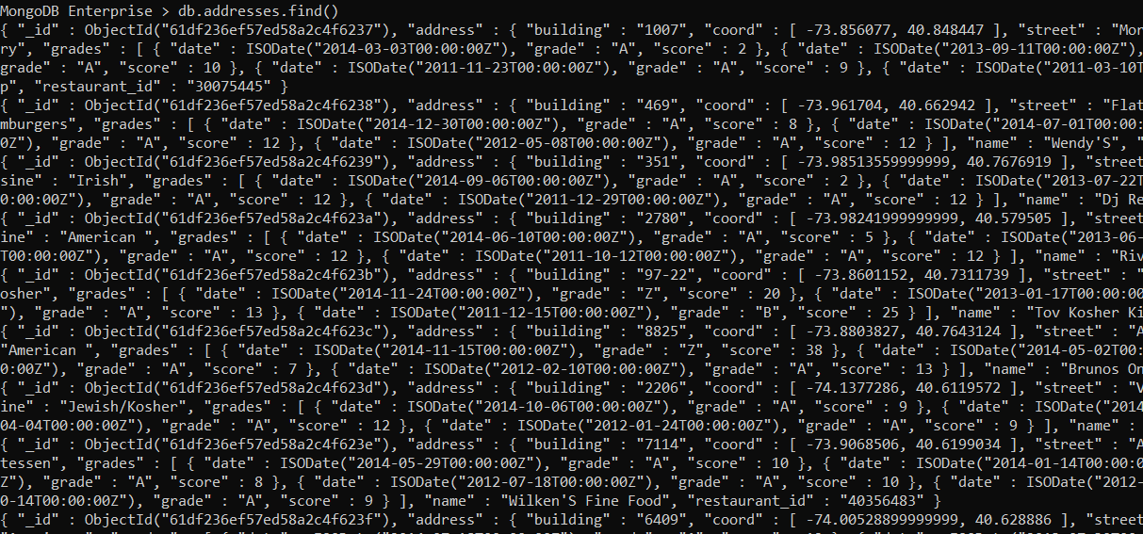
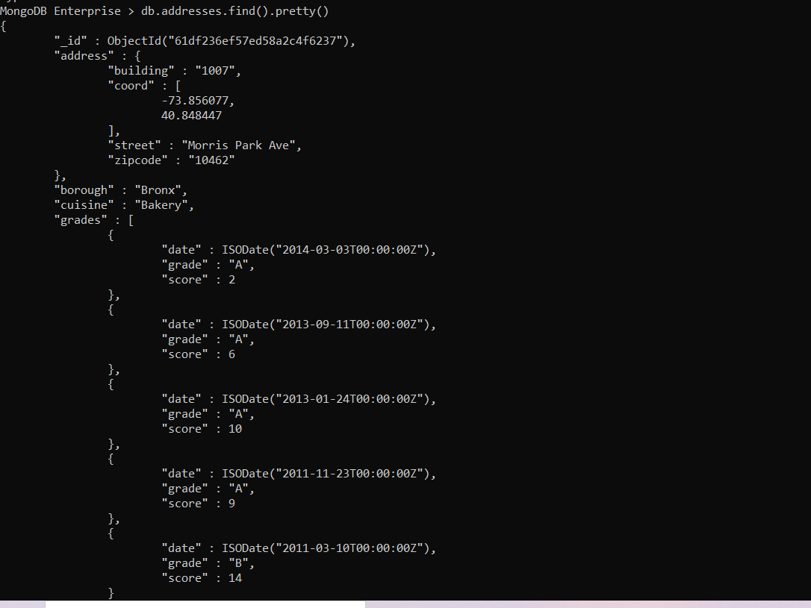

- Write a MongoDB query to display the fields restaurant_id, name, borough and cuisine for all the documents in the collection restaurant.

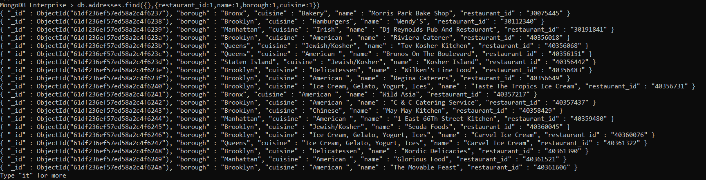
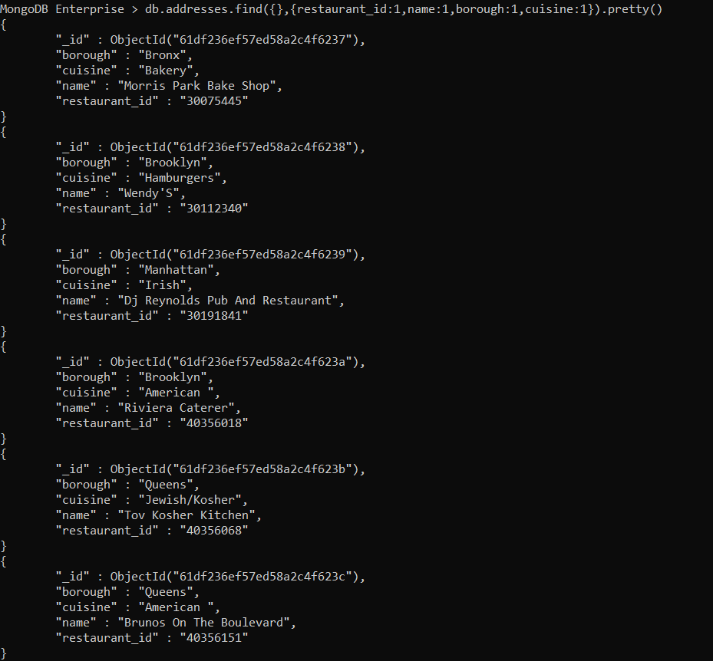

- Write a MongoDB query to display the fields restaurant_id, name, borough and cuisine, but exclude the field _id for all the documents in the collection restaurant.

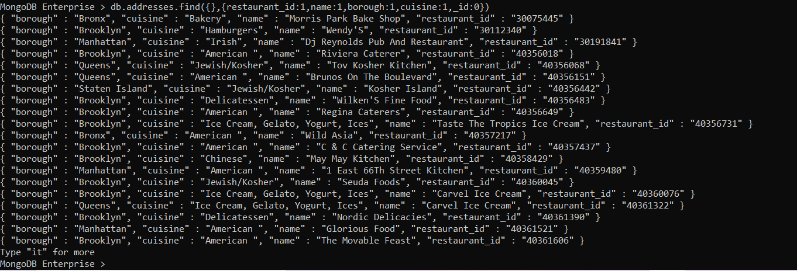

- Write a MongoDB query to display the fields restaurant_id, name, borough and zip code, but exclude the field _id for all the documents in the collection restaurant.

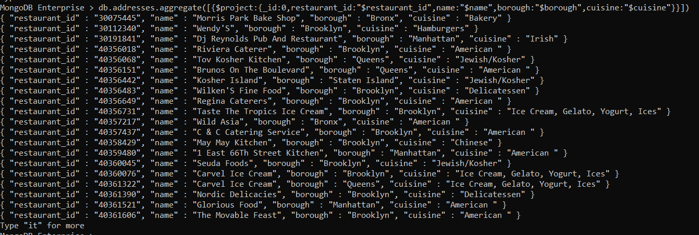

- Write a MongoDB query to display the first 5 restaurant which is in the borough Bronx.

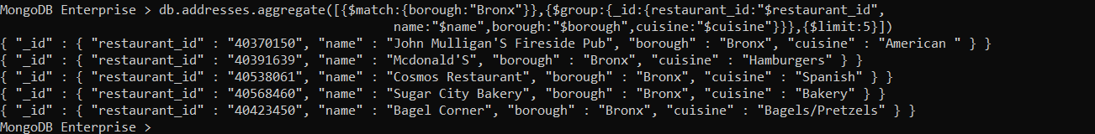

- Write a MongoDB query to display all the restaurant which is in the borough Bronx.

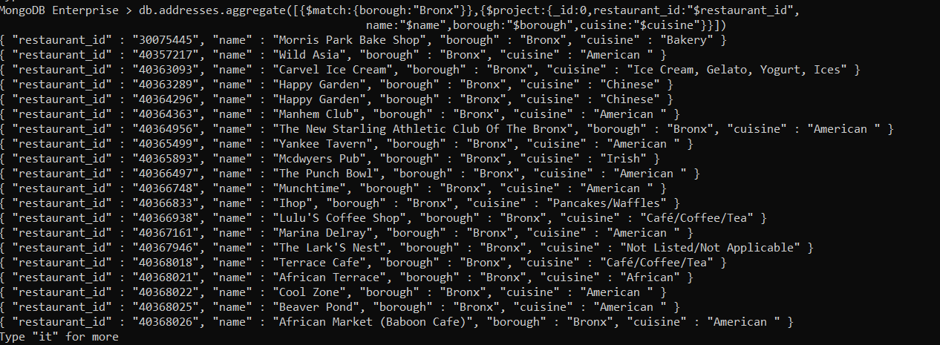

- Write a MongoDB query to display the next 5 restaurants after skipping first 5 which are in the borough Bronx.

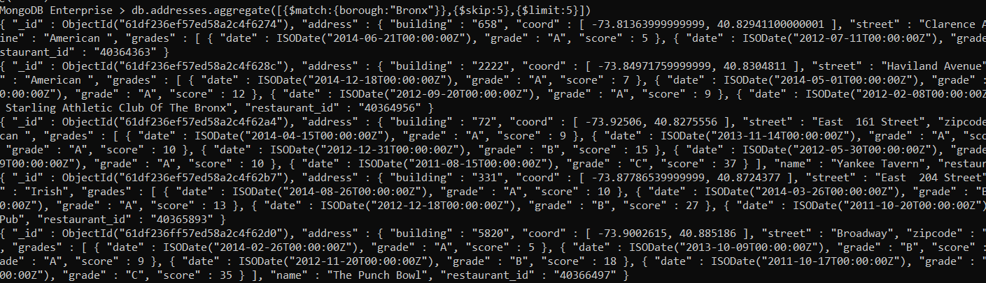
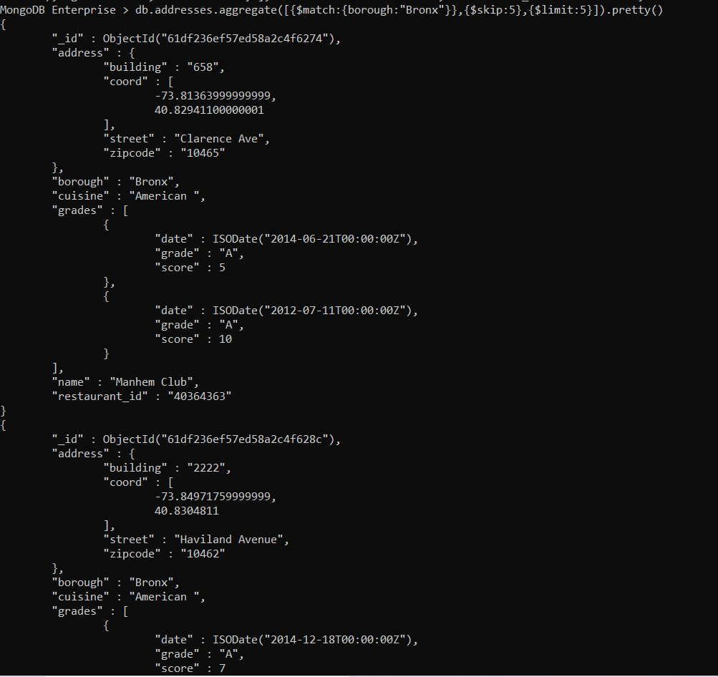

- Write a MongoDB query to find the restaurants who achieved a score more than 90.

- Write a MongoDB query to find the restaurants that achieved a score, more than 80 but less than 100.

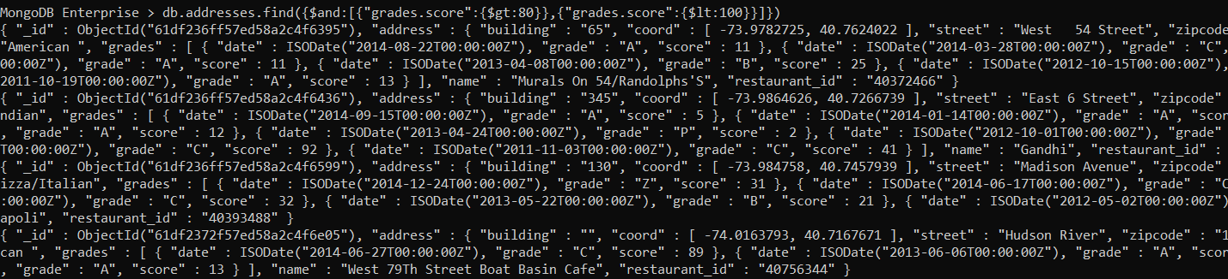

- Write a MongoDB query to find the restaurants which locate in latitude value less than -95.754168.
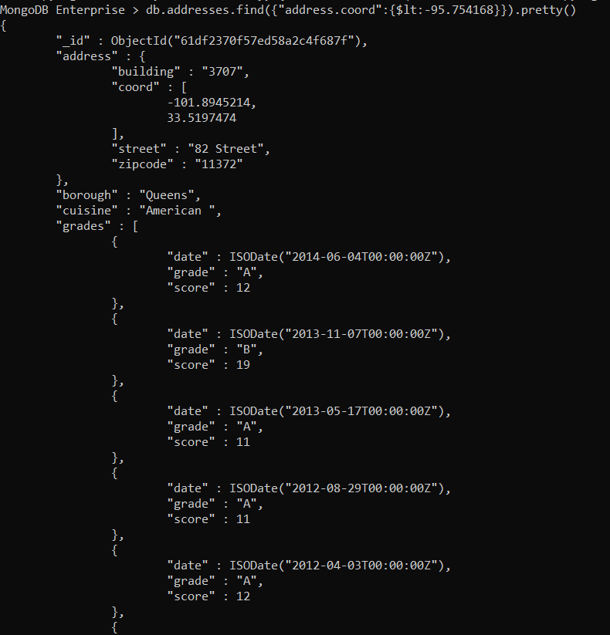

- Write a MongoDB query to find the restaurants that do not prepare any cuisine of 'American' and their grade score more than 70 and latitude less than -65.754168.
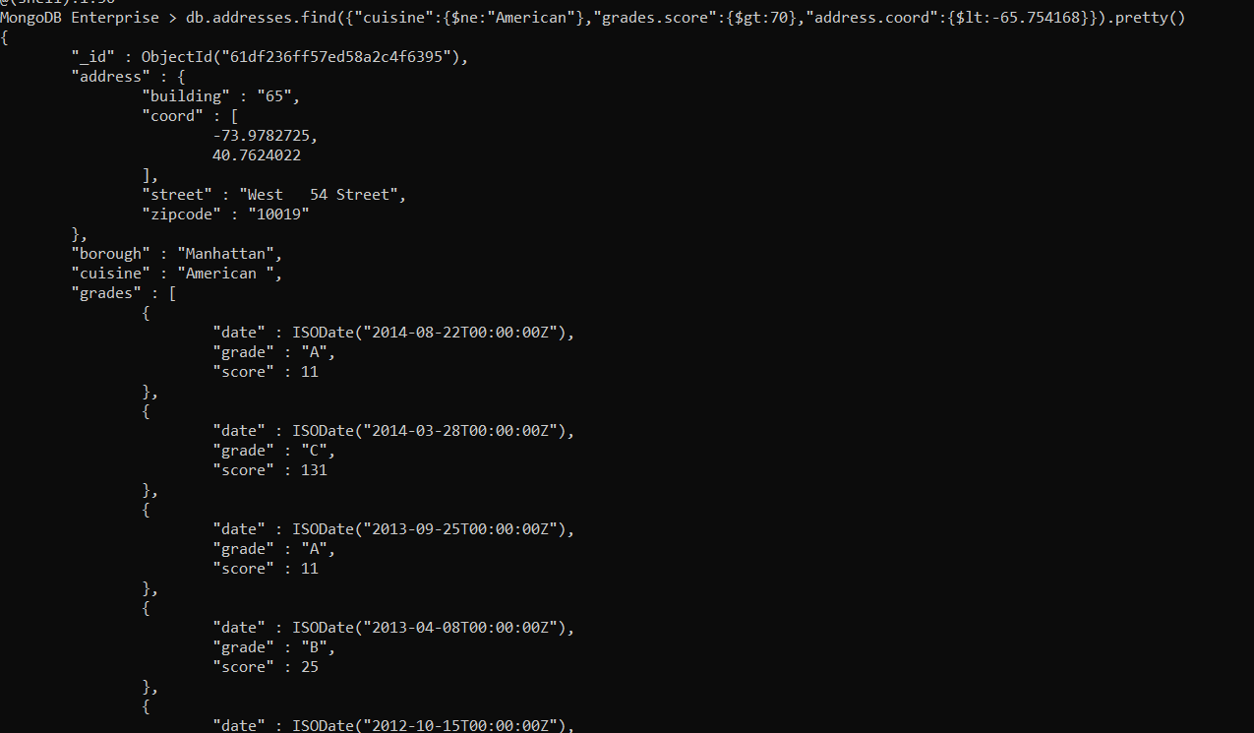
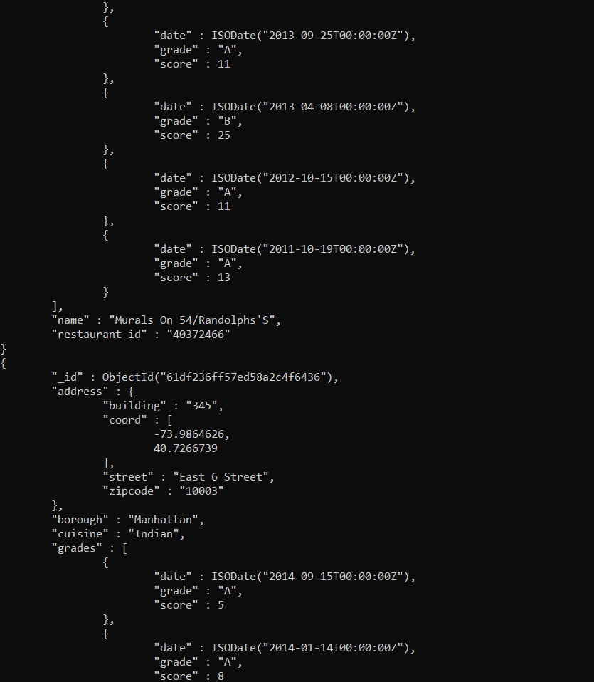

- Write a MongoDB query to find the restaurants which do not prepare any cuisine of 'American' and achieved a score more than 70 and located in the longitude less than -65.754168.

- Write a MongoDB query to find the restaurants which do not prepare any cuisine of 'American ' and achieved a grade point 'A' not belongs to the borough Brooklyn. The document must be displayed according to the cuisine in descending order.
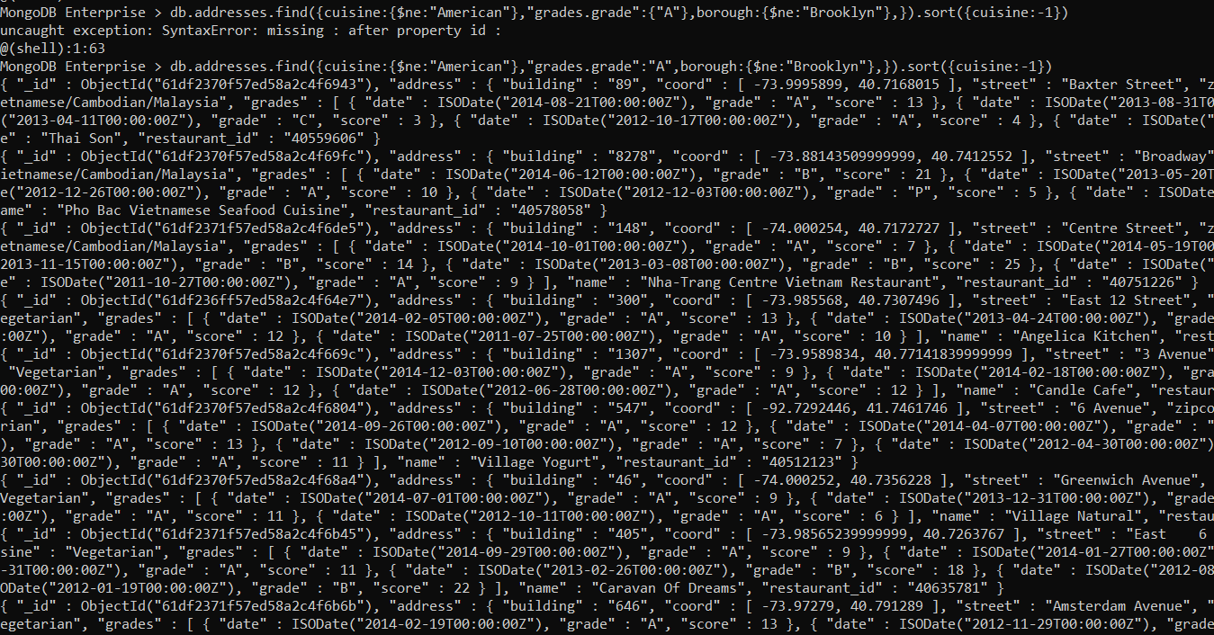

- Write a MongoDB query to find the restaurant Id, name, borough and cuisine for those restaurants which contain 'Wil' as first three letters for its name.

- Write a MongoDB query to find the restaurant Id, name, borough and cuisine for those restaurants which contain 'ces' as last three letters for its name.

- Write a MongoDB query to find the restaurant Id, name, borough and cuisine for those restaurants which contain 'Reg' as three letters somewhere in its name.
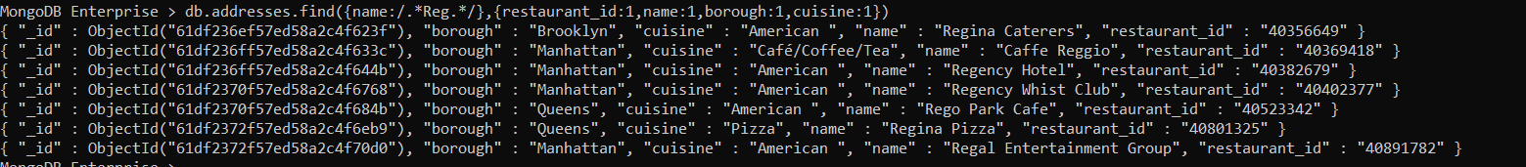

- Write a MongoDB query to find the restaurants which belong to the borough Bronx and prepared either American or Chinese dish.
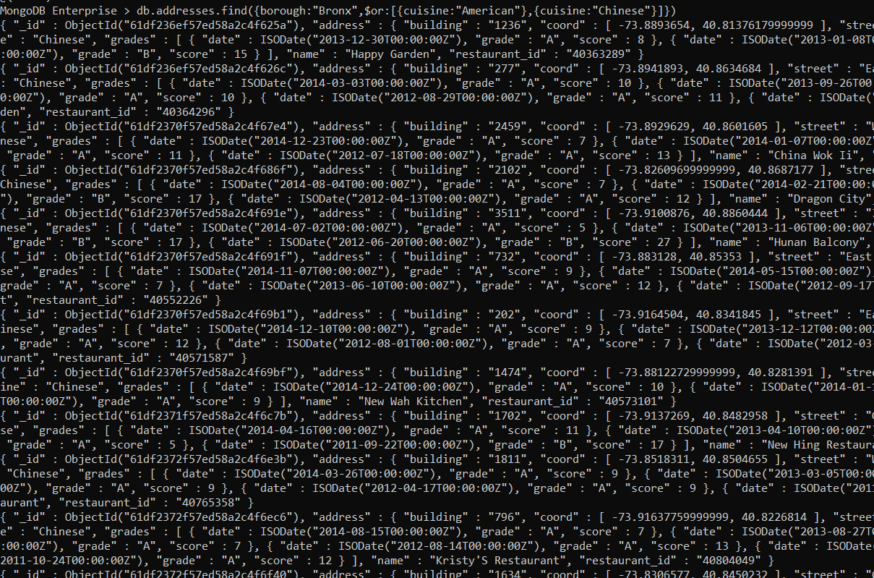

- Write a MongoDB query to find the restaurant Id, name, borough and cuisine for those restaurants which belong to the borough Staten Island or Queens or Bronx or Brooklyn.
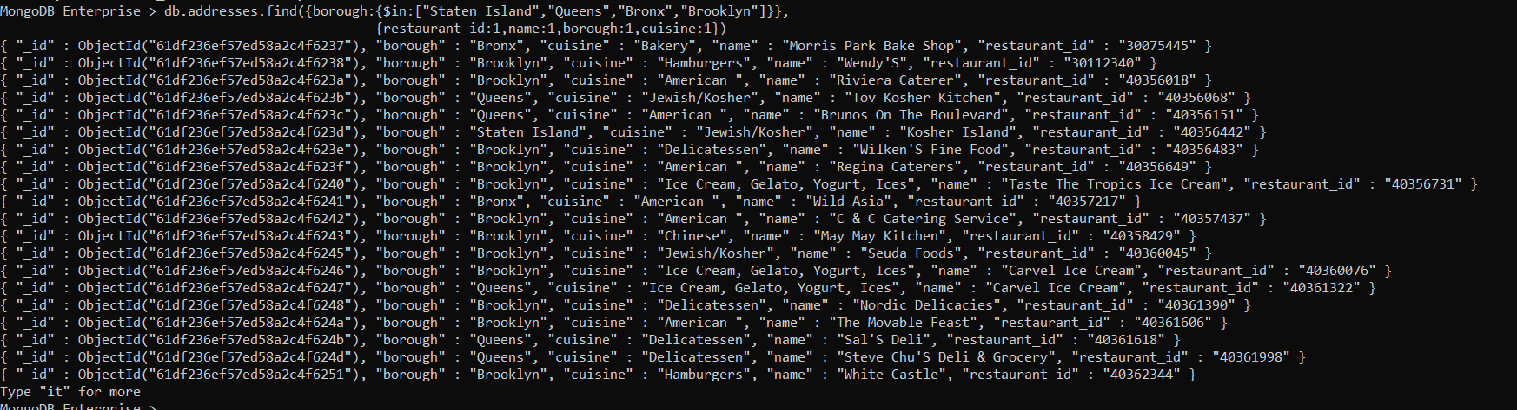

- Write a MongoDB query to find the restaurant Id, name, borough and cuisine for those restaurants which are not belonging to the borough Staten Island or Queens or Bronxor Brooklyn.
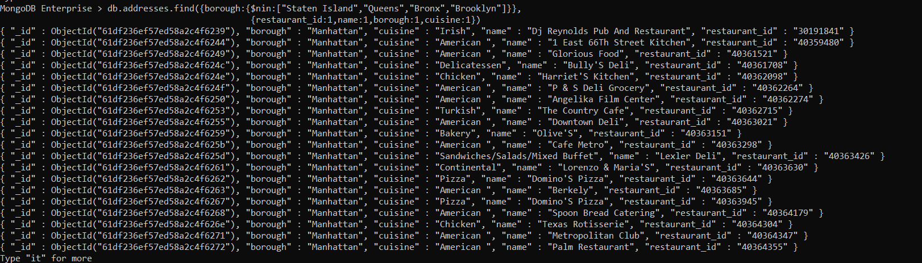

- Write a MongoDB query to find the restaurant Id, name, borough and cuisine for those restaurants which achieved a score which is not more than 10.

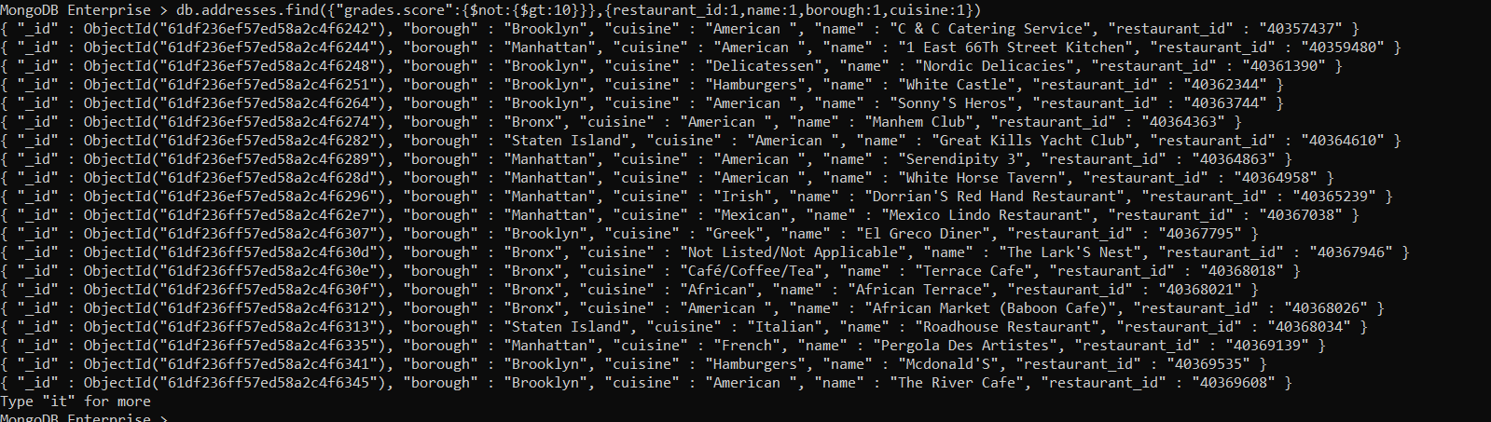

- Write a MongoDB query to find the restaurant Id, name, borough and cuisine for those restaurants which prepared dish except 'American' and 'Chinees' or restaurant's name begins with letter 'Wil'.

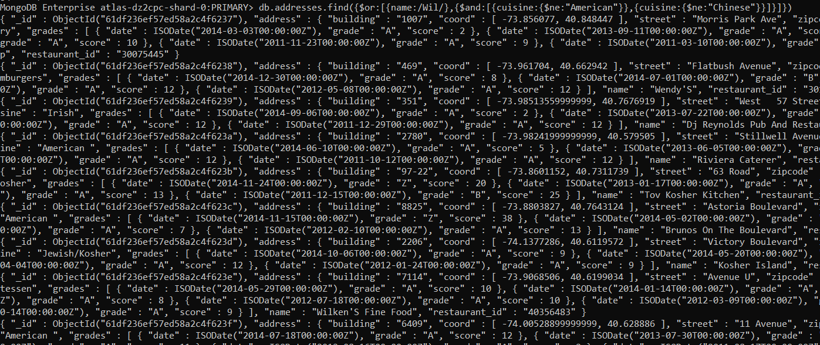

- Write a MongoDB query to find the restaurant Id, name, and grades for those restaurants which achieved a grade of "A" and scored 11 on an ISODate "2014-08-11T00:00:00Z" among many of survey dates..
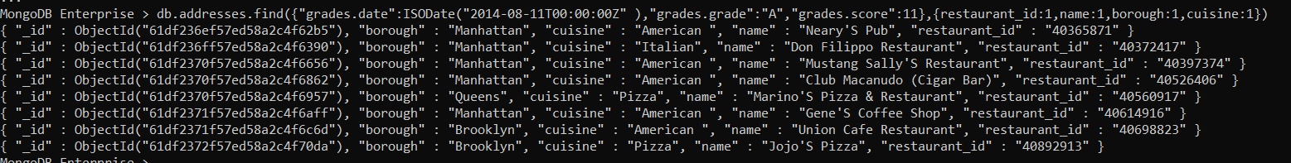

- Write a MongoDB query to find the restaurant Id, name and grades for those restaurants where the 2nd element of grades array contains a grade of "A" and score 9 on an ISODate "2014-08-11T00:00:00Z"

- Write a MongoDB query to find the restaurant Id, name, address and geographical location for those restaurants where 2nd element of coord array contains a value which is more than 42 and upto 52.
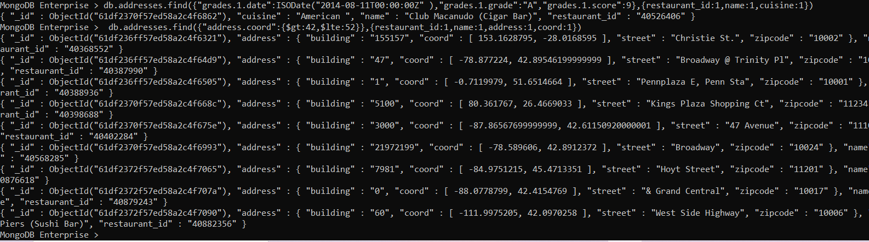

- Write a MongoDB query to arrange the name of the restaurants in ascending order along with all the columns.
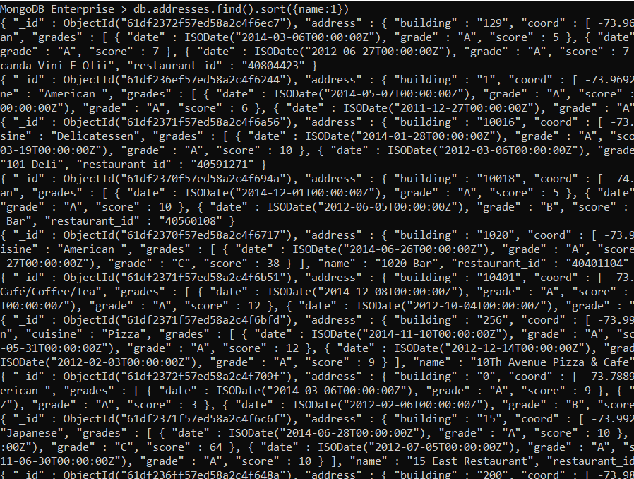

- Write a MongoDB query to arrange the name of the restaurants in descending along with all the columns.
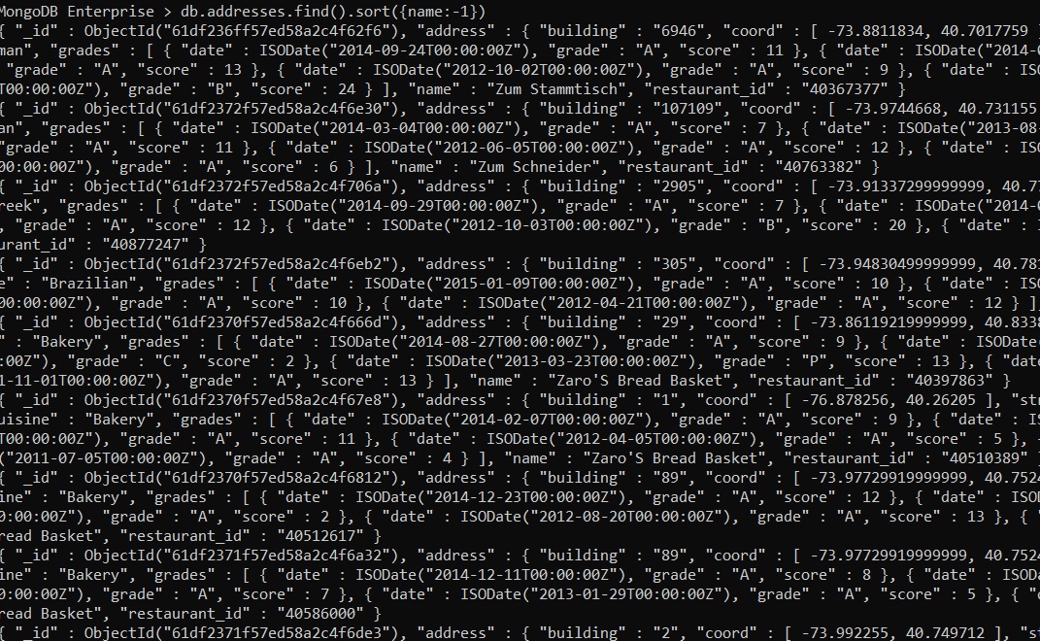

- Write a MongoDB query to arranged the name of the cuisine in ascending order and for that same cuisine borough should be in descending order.
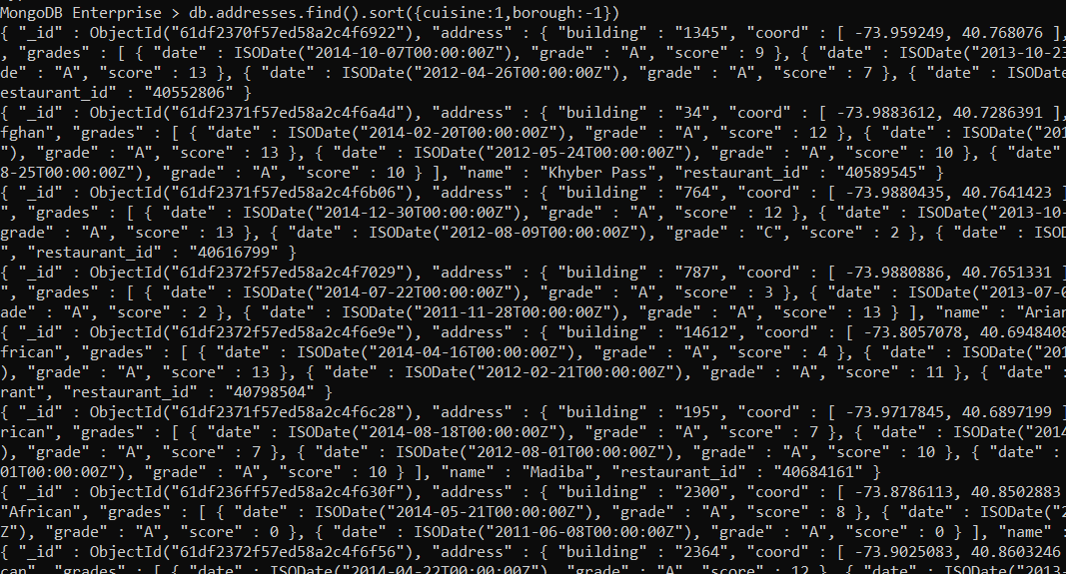

- Write a MongoDB query to know whether all the addresses contains the street or not.
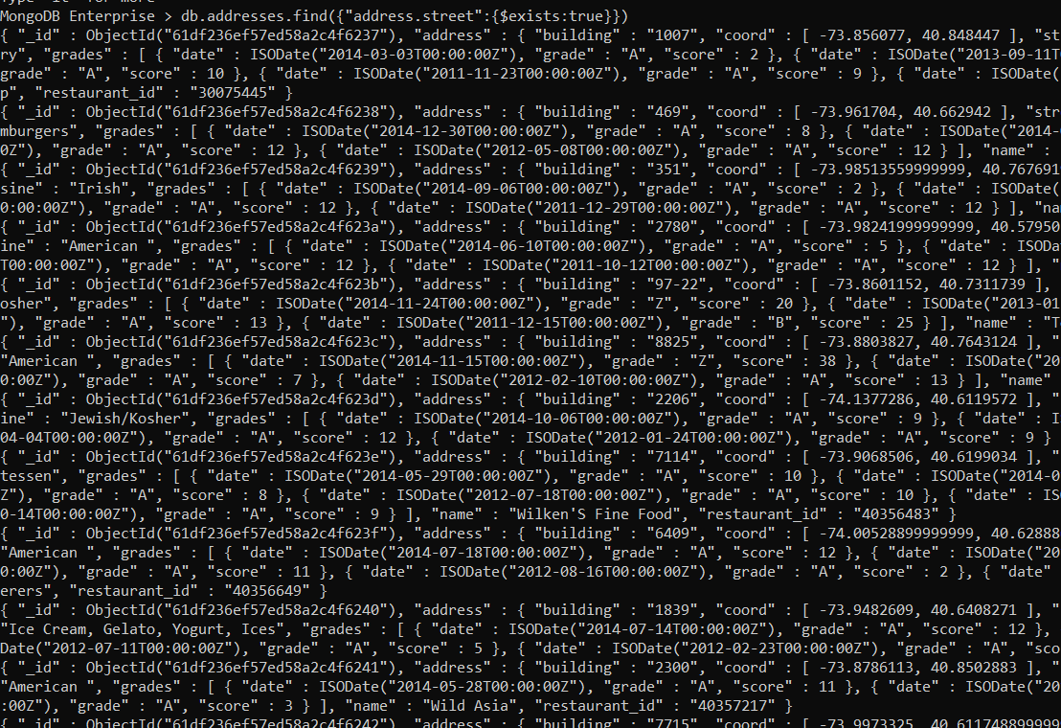

- Write a MongoDB query which will select all documents in the restaurants collection where the coord field value is Double.
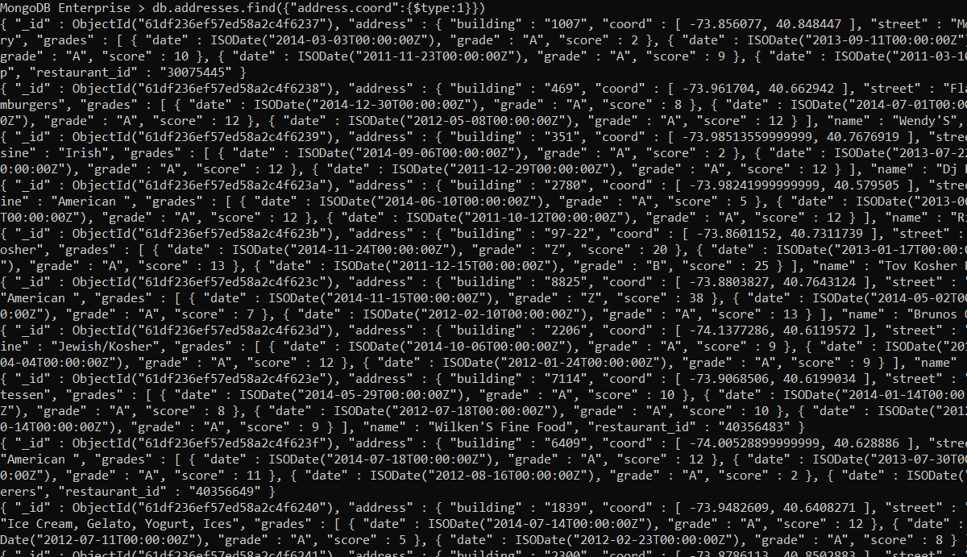

- Write a MongoDB query which will select the restaurant Id, name and grades for those restaurants which returns 0 as a remainder after dividing the score by 7.

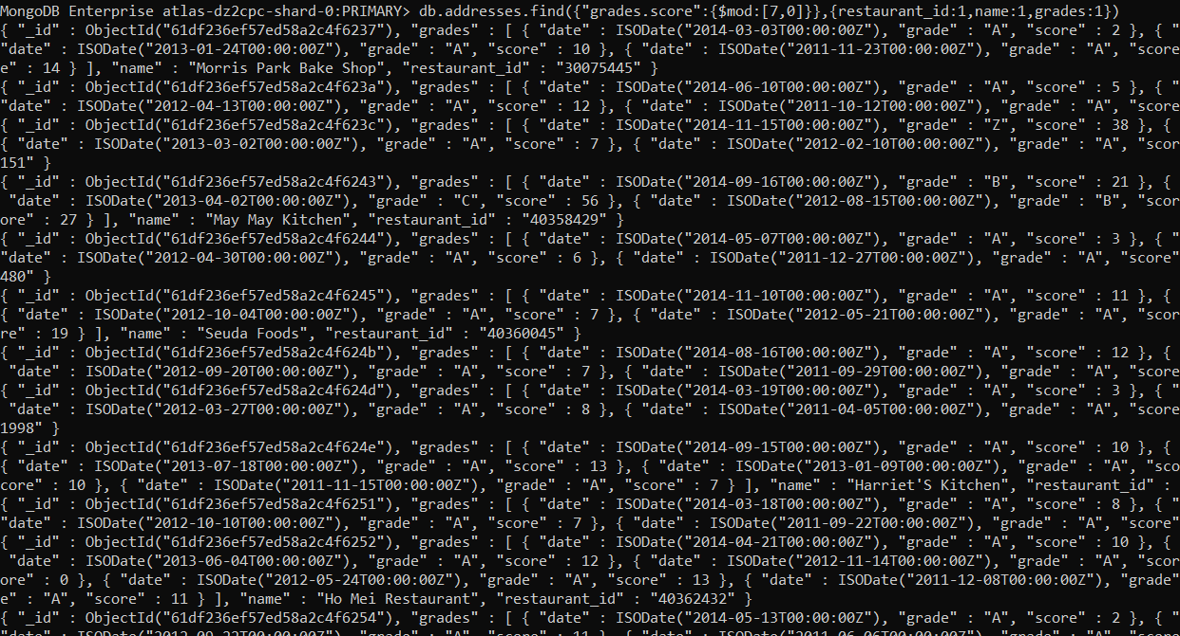

- Write a MongoDB query to find the restaurant name, borough, longitude and attitude and cuisine for those restaurants which contains 'mon' as three letters somewhere in its name.

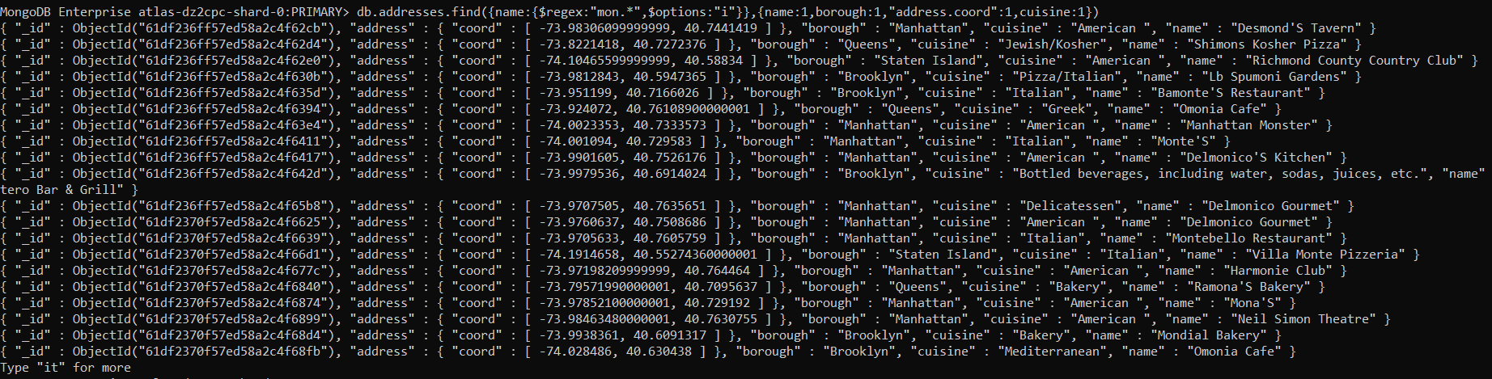

- Write a MongoDB query to find the restaurant name, borough, longitude and latitude and cuisine for those restaurants which contain 'Mad' as first three letters of its name.

